**Given a list of numbers - List[Int] (1, 2, 3, 4, 5, 6, 7, 8, 9, 10)**

**- find the sum of all numbers**

val list = List(1, 2, 3, 4, 5, 6, 7, 8, 9, 10);

list.sum;

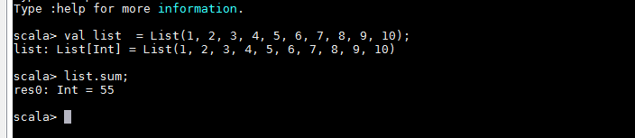

- **find the total elements in the list**

val list = List(1, 2, 3, 4, 5, 6, 7, 8, 9, 10);

list.length;



- **calculate the average of the numbers in the list**

val list = List(1, 2, 3, 4, 5, 6, 7, 8, 9, 10);

list.sum / list.size.toDouble;

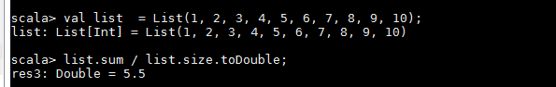

- **find the sum of all the even numbers in the list**

val list = List(1, 2, 3, 4, 5, 6, 7, 8, 9, 10);

list.filter(_ % 2 == 0).sum;



- **find the total number of elements in the list divisible by both 5 and 3**

val list = List(1, 2, 3, 4, 5, 6, 7, 8, 9, 10);

list.filter(i => i % 3 == 0 && i % 5 == 0)

